**CLOUD COMPUTING LAB**

**Name: Maria Abdul Malik**

**Reg No: 2023-BSE-076**

**Submitted to: Sir Muhammad Shoaib**

**Class: 5B**

**LAB #14**

# Task 0 – Lab Setup (Codespace & GH CLI)

* task0_codespace_open.png

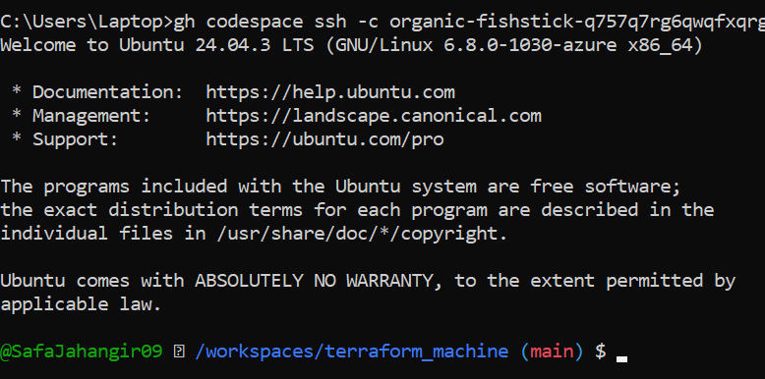

* task0_env_check.png

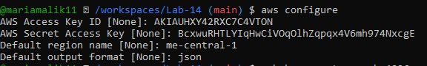

* task0_aws_config.png

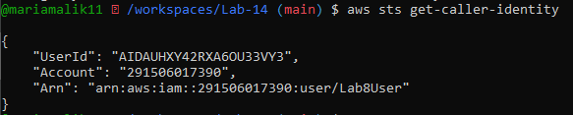

# Task 1 – Generate ssh key and Initial Terraform apply

* task1_ssh_keygen_before.png



* task1_ssh_keygen.png

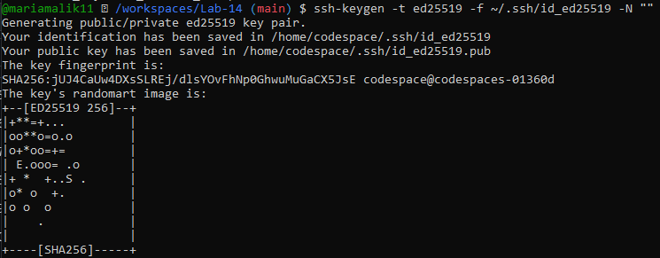

* task1_ssh_keygen_after.png

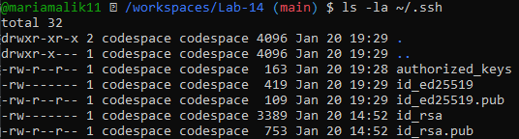

* task1_terraform_tfvars_created.png



* task1_terraform_tfvars.png

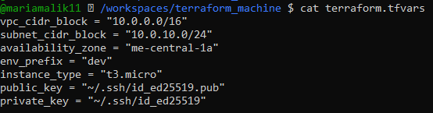

* task1_terraform_init.png

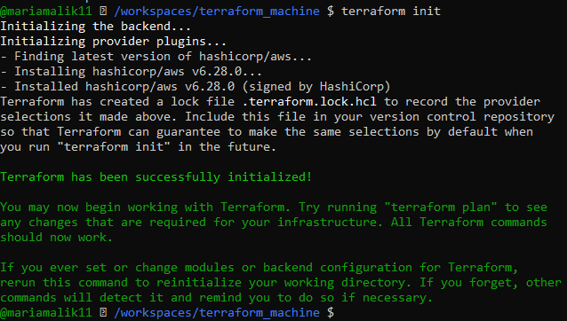

* task1_terraform_apply_2_instances.png

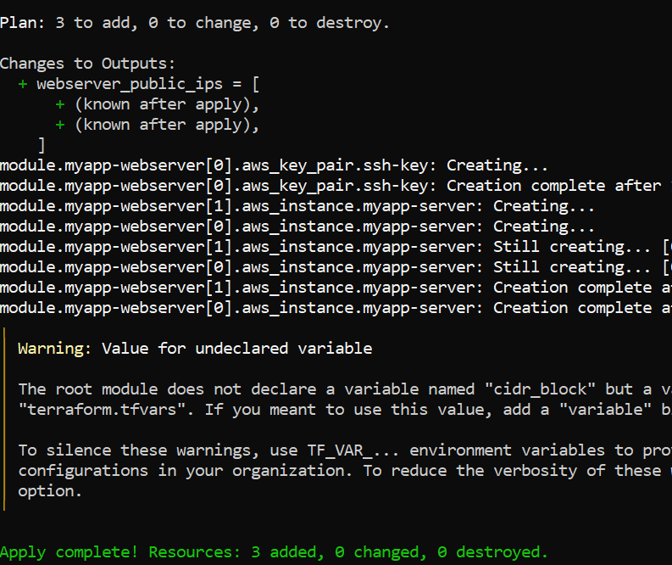

* task1_terraform_output_ips.png

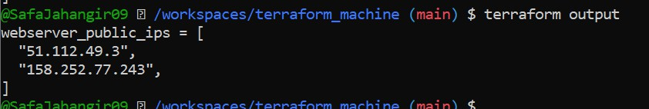

# Task 2 – Static Ansible inventory with two EC2 instances

* task2_ansible_install.png

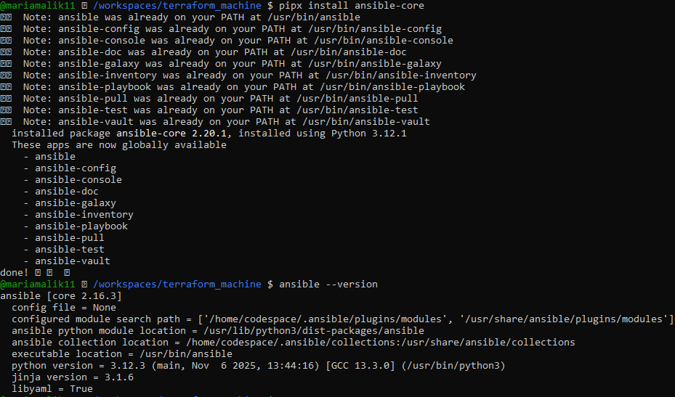

* task2_terraform_output_ips.png

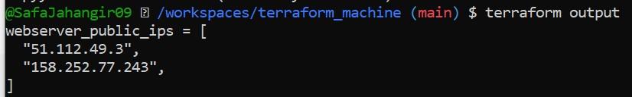

* task2_hosts_created.png

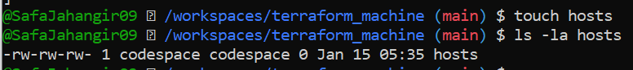

* task2_hosts_initial.png



* task2_ansible_ping_initial.png

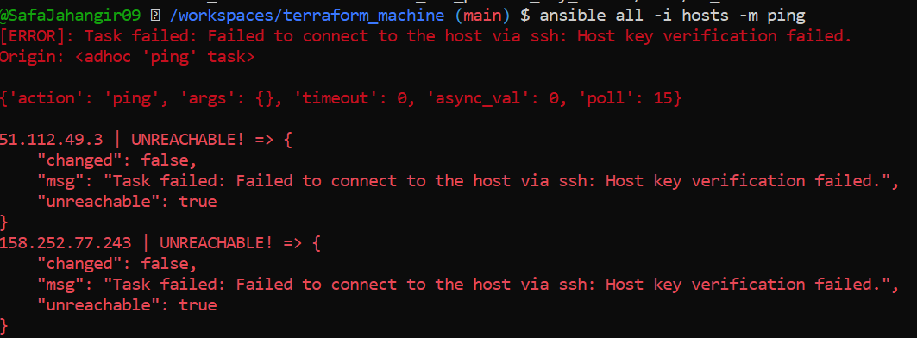

* task2_hosts_with_common_args.png

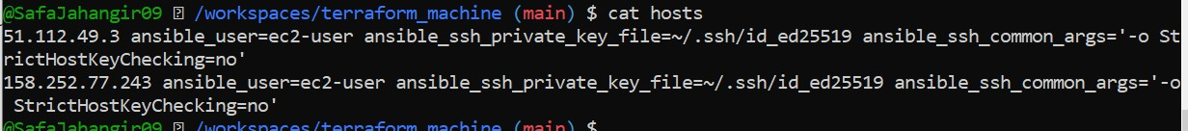

* task2_ansible_ping_success.png

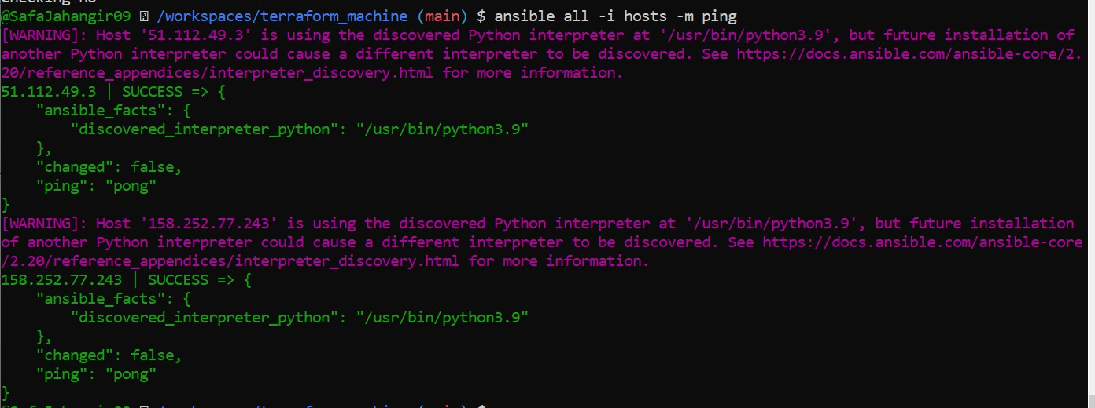

# Task 3 - Scale to three instances & group-based inventory

* task3_main_tf_count_3.png

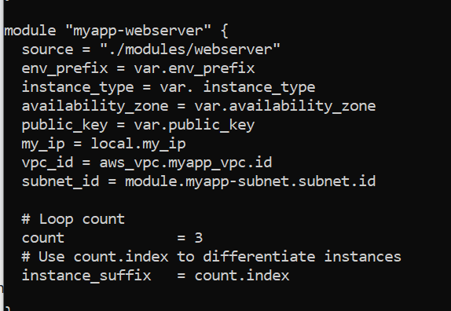

* task3_terraform_apply_3_instances.png

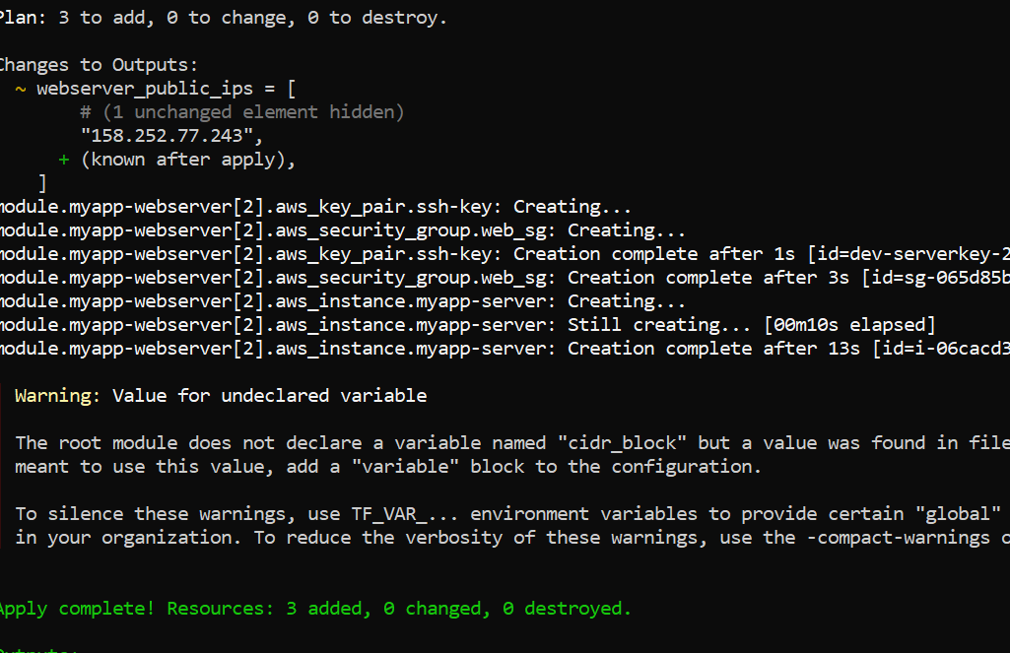

* task3_terraform_output_3_ips.png

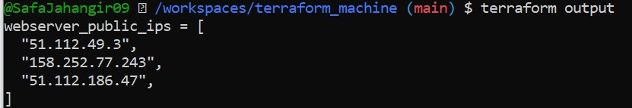

* task3_hosts_grouped.png

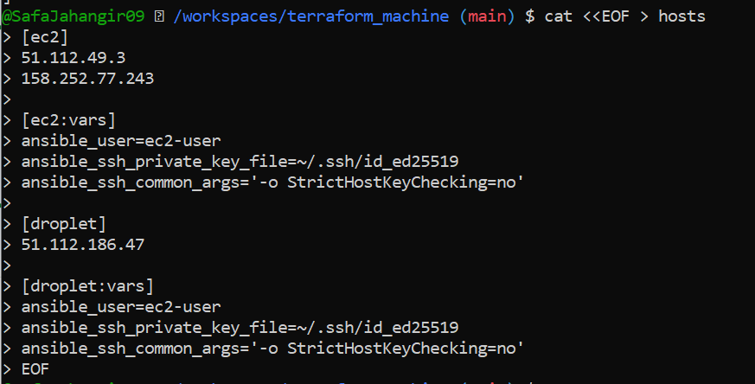

* task3_ansible_ec2_ping.png

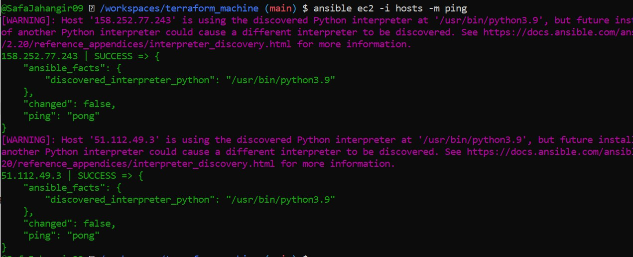

* task3_ansible_single_ip_ping.png

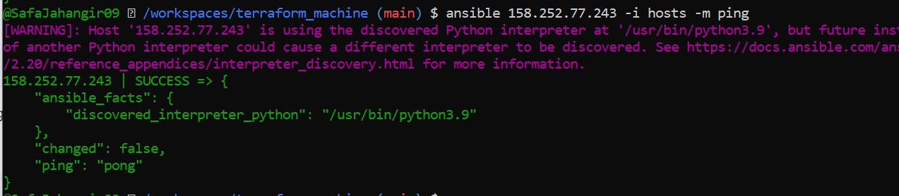

* task3_ansible_droplet_ping.png

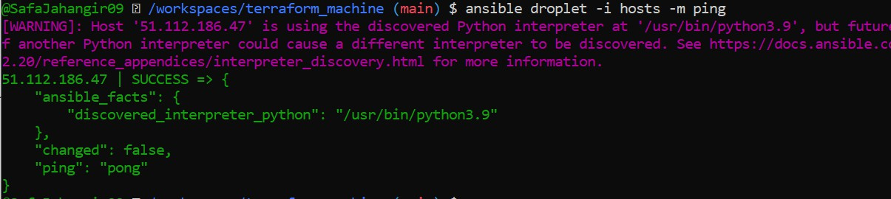

* task3_ansible_all_ping.png

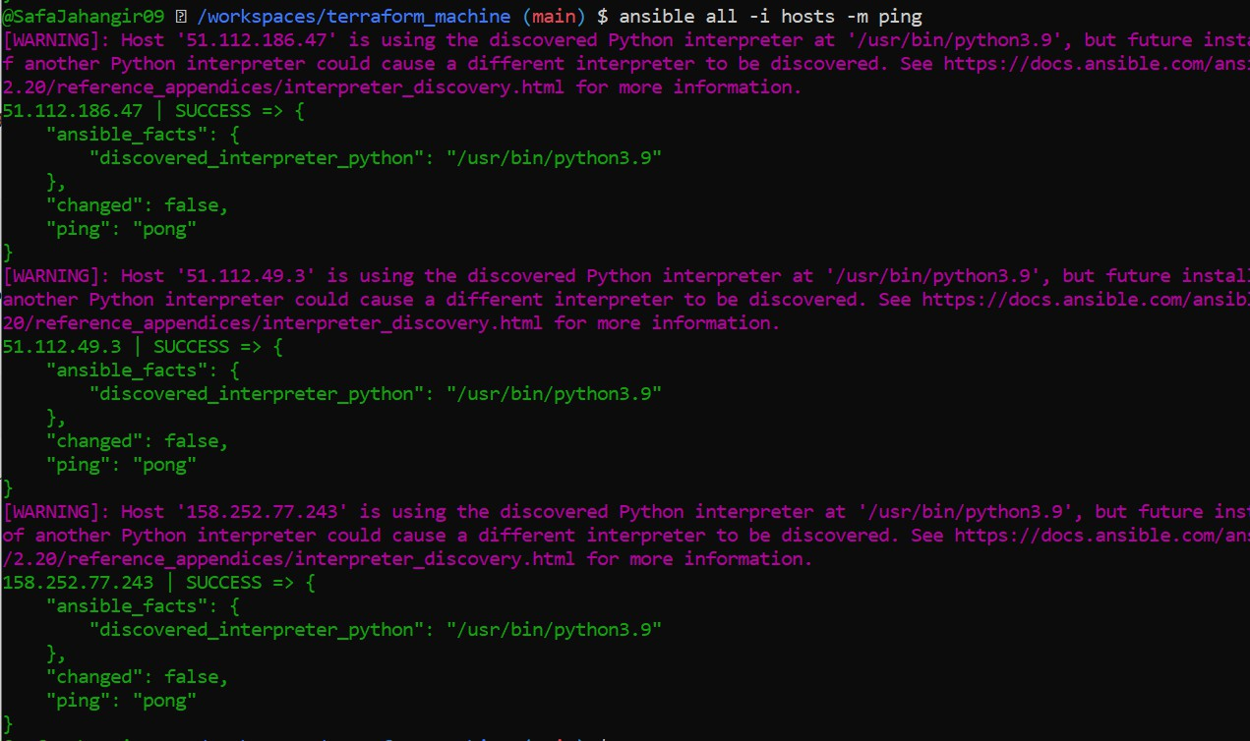

# Task 4 – Global ansible.cfg & first nginx playbook

* task4_global_ansible_cfg.png

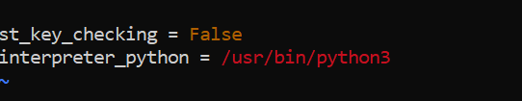

* task4_hosts_without_common_args.png

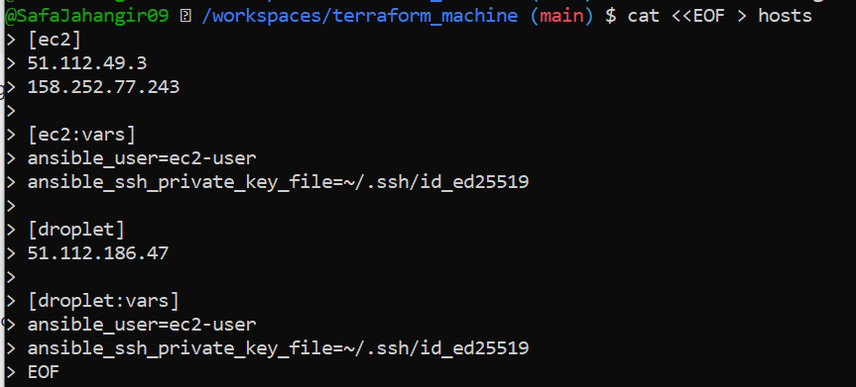

* task4_ansible_ping_after_cfg.png

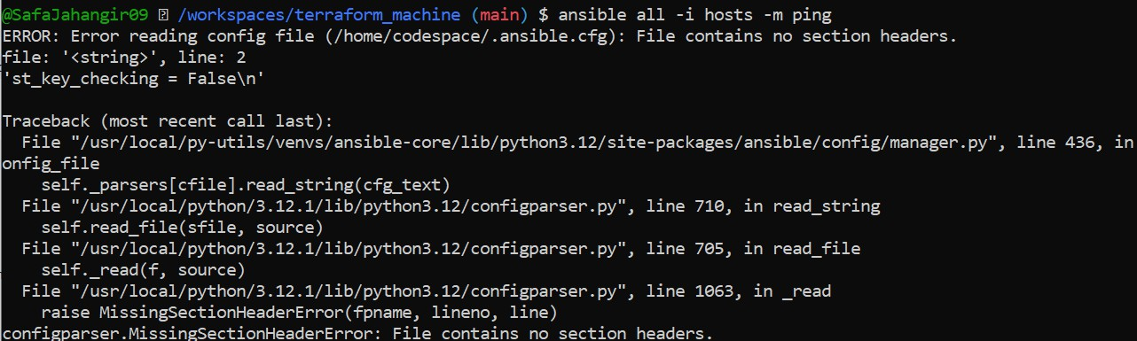

* task4_my_playbook_created.png





* task4_my_playbook_ec2.png

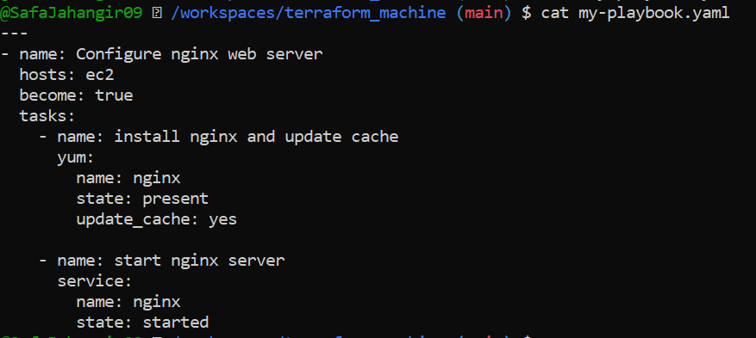

* task4_ansible_play_ec2.png

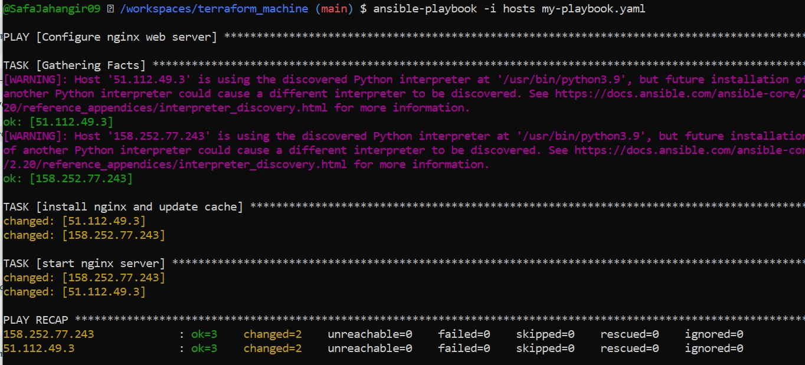

* task4_nginx_browser_ec2.png

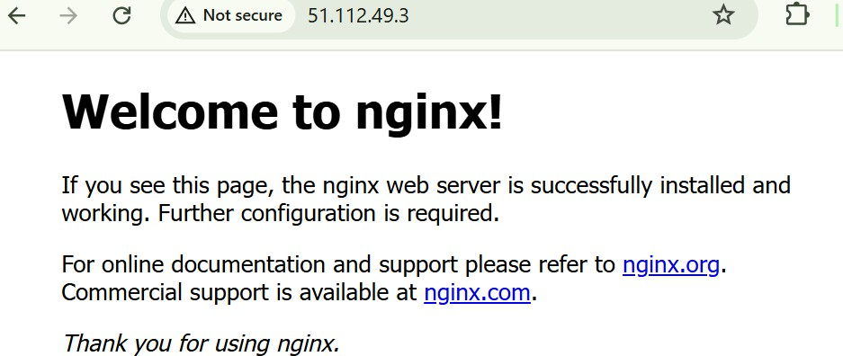

* task4_my_playbook_droplet.png

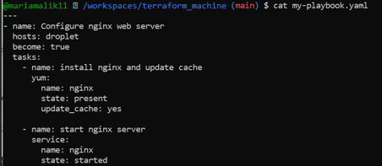

* task4_ansible_play_droplet.png

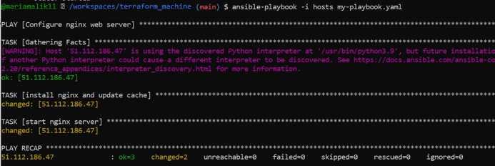

* task4_nginx_browser_droplet.png

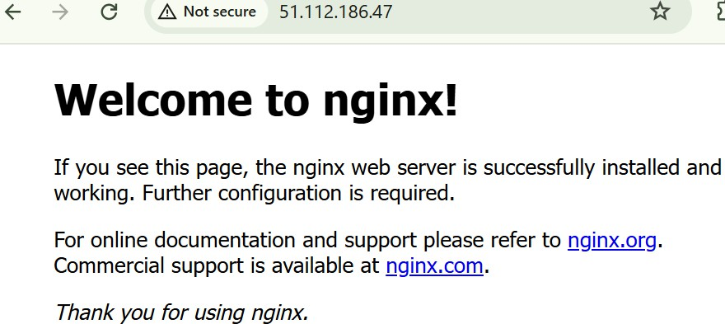

# Task 5 – Single nginx target group & HTTPS prerequisites

* task5_project_ansible_cfg_created.png



* task5_project_ansible_cfg.png

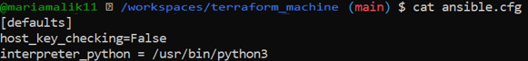

* task5_main_tf_count_1.png

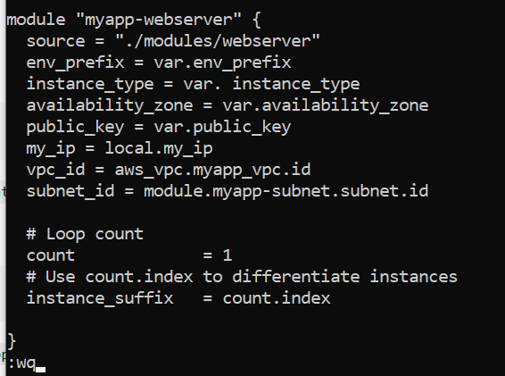

* task5_terraform_apply_one_instance.png

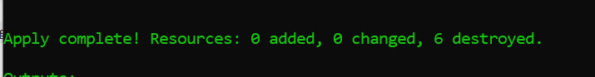

* task5_terraform_output_single_ip.png

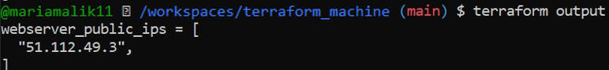

* task5_hosts_nginx_group.png

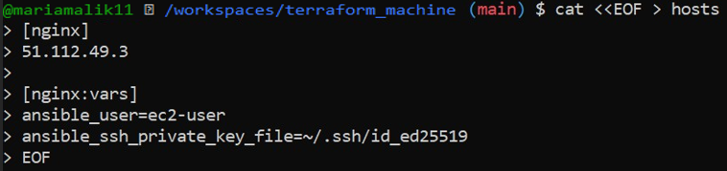

* task5_my_playbook_nginx_group.png

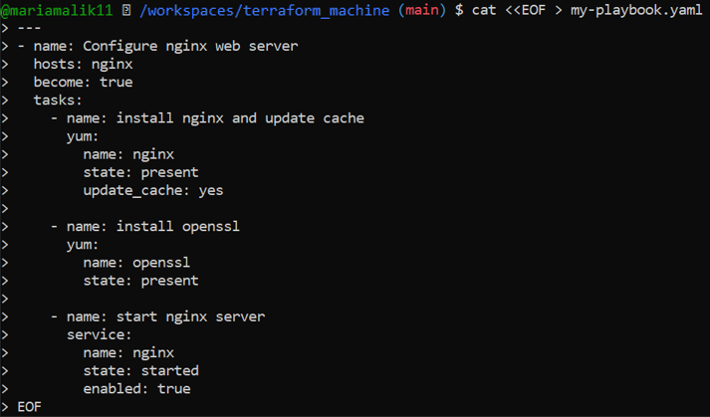

* task5_ansible_play_nginx_group.png

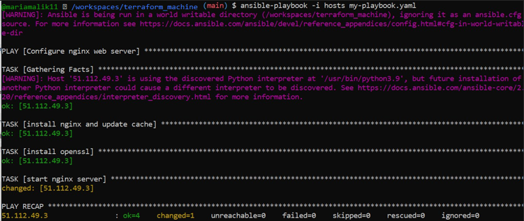

* task5_nginx_browser_single.png

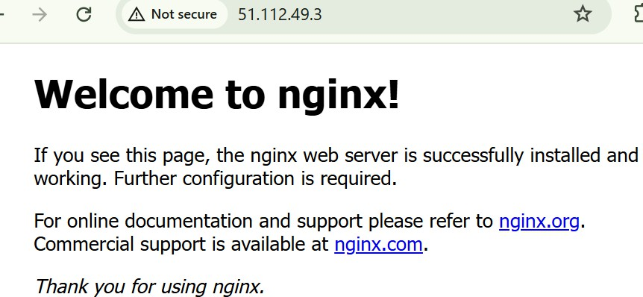

# Task 6 - Ansible-managed SSL certificates

* task6_my_playbook_ssl_section.png

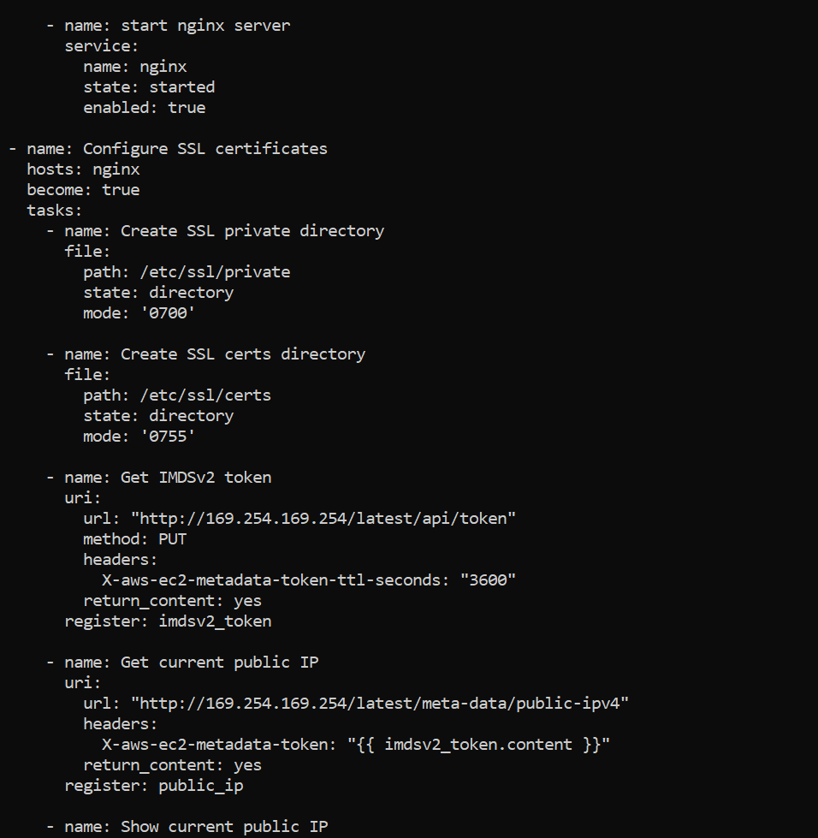

* task6_ansible_play_ssl.png

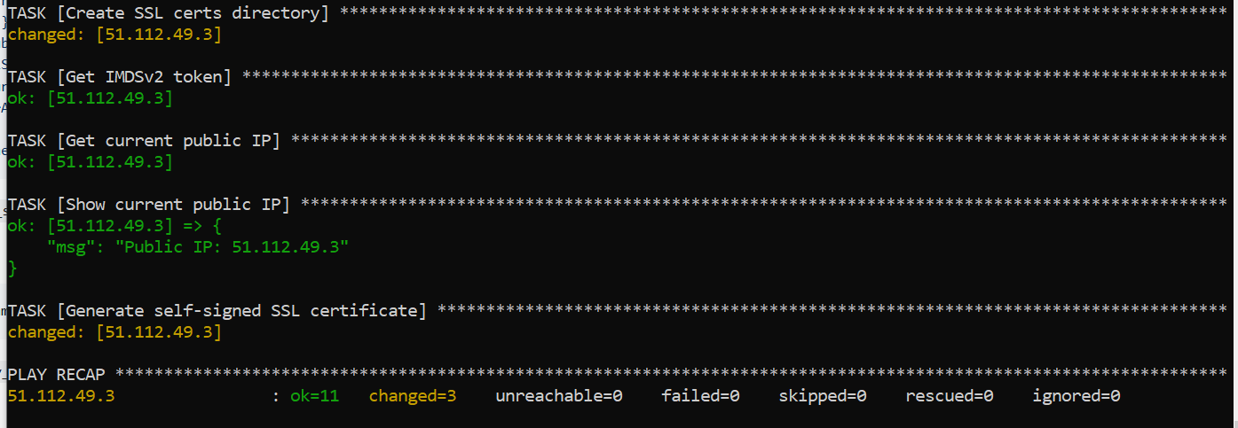

* task6_ssl_cert_file.png

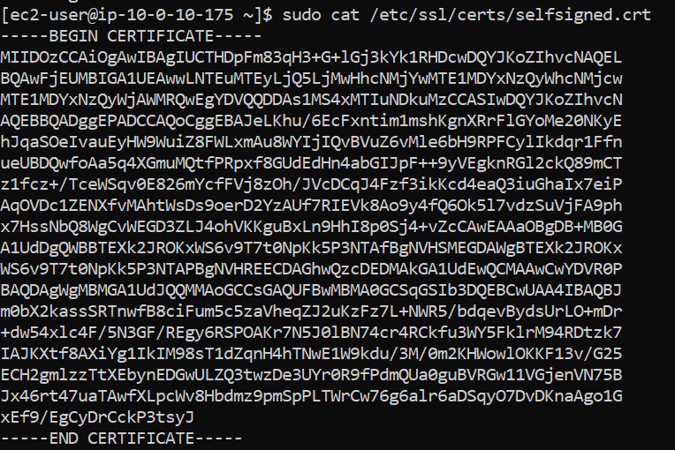

* task6_ssl_key_file.png

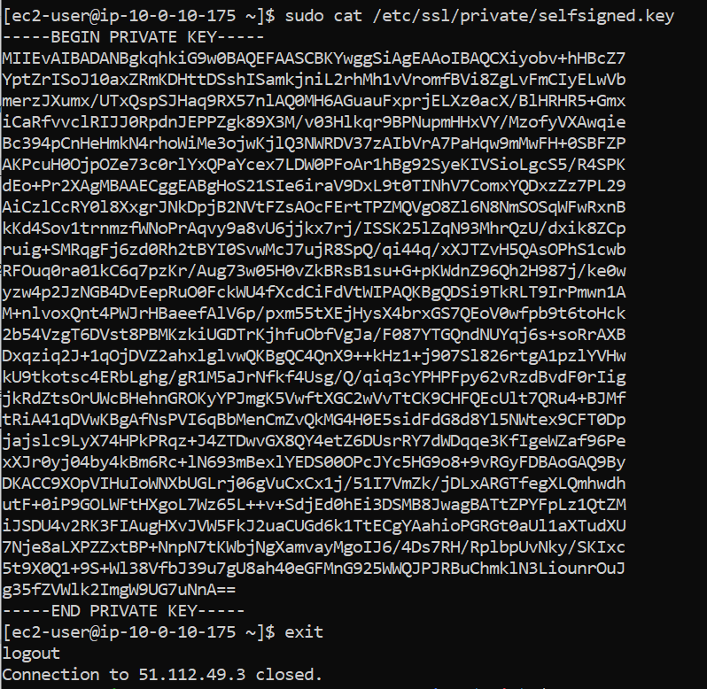

# Task 7 - PHP front-end deployment with templates

* task7_files_templates_created.png

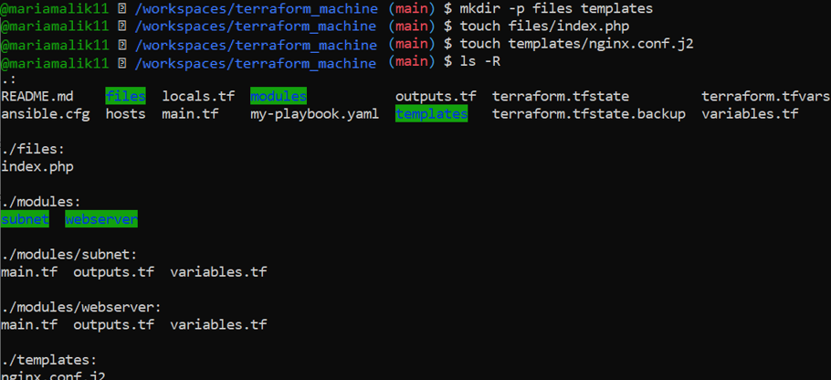

* task7_index_php_content.png

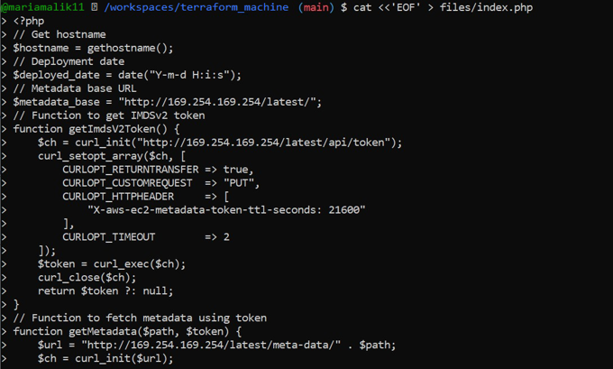

* task7_nginx_conf_template.png

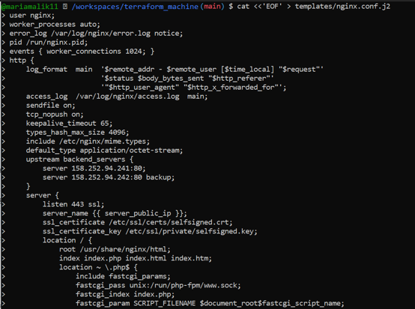

* task7_my_playbook_web_deploy.png

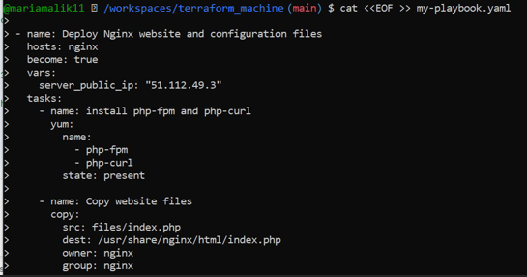

* task7_ansible_play_web_deploy.png

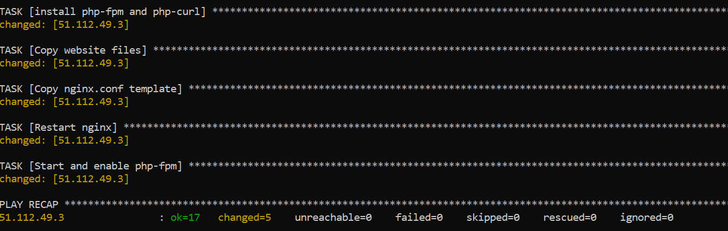

* task7_php_https_browser.png

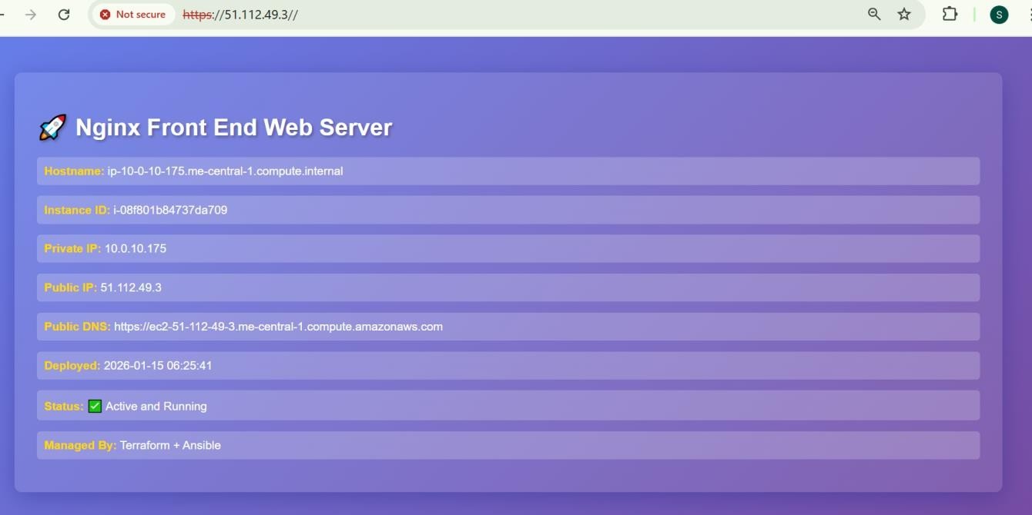

# Task 8 – Docker & Docker Compose provisioning via Ansible

* task8_terraform_destroy_old.png

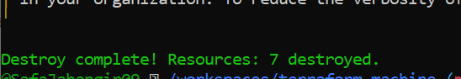

* task8_terraform_apply_docker_instance.png

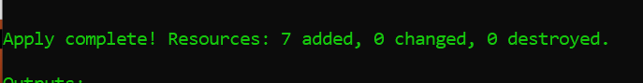

* task8_terraform_output_new_ip.png

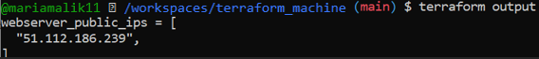

* task8_hosts_docker_servers.png

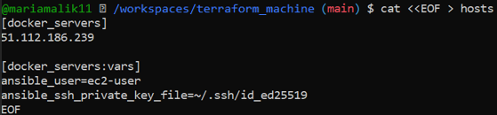

* task8_my_playbook_docker.png

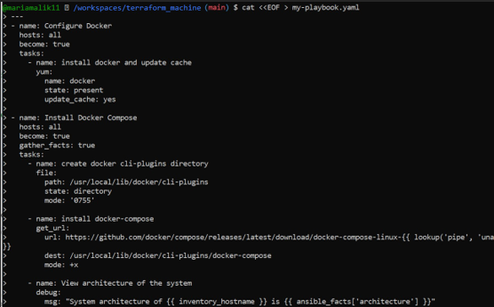

* task8_ansible_play_docker.png

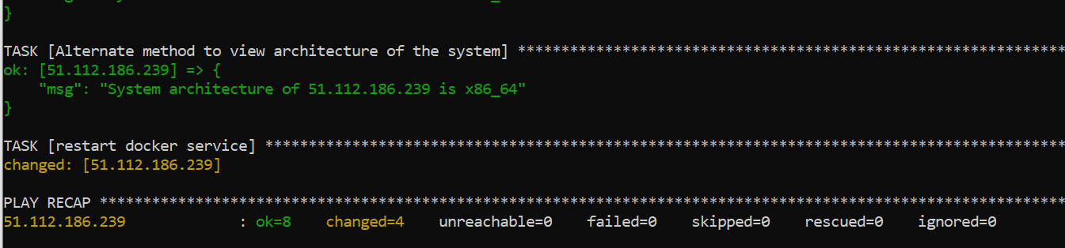

* task8_docker_ps_remote.png

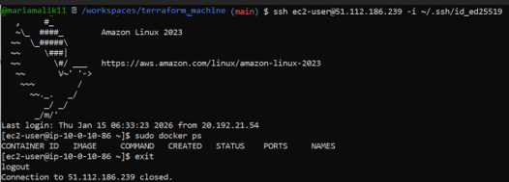

# Task 9 – Gitea Docker stack via Ansible + Terraform security group update

* task9_my_playbook_add_user_to_docker.png

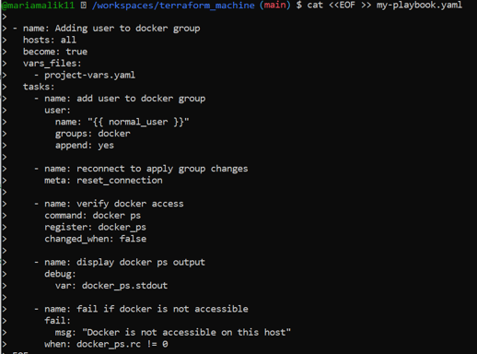

* task9_project_vars.png

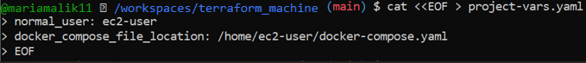

* task9_my_playbook_deploy_containers.png

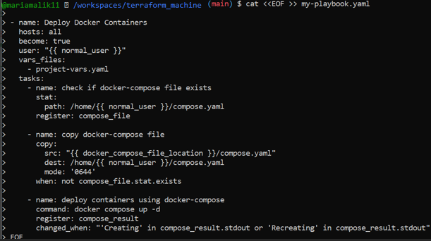

* task9_compose_yaml.png

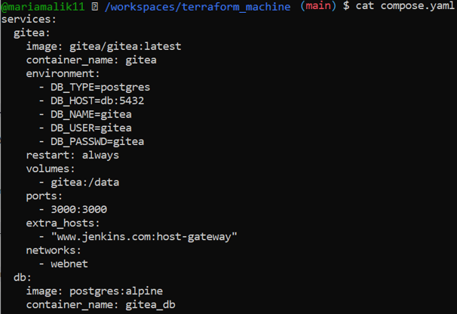

* task9_ansible_play_gitea.png

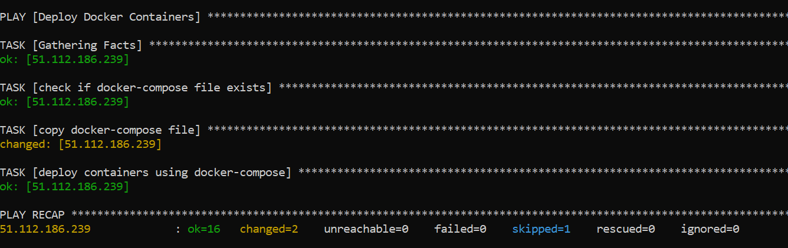

* task9_sg_ingress_3000.png

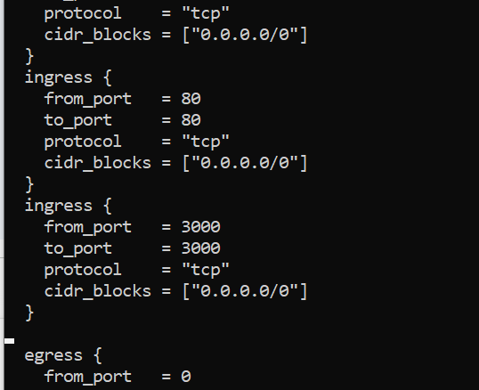

* task9_terraform_apply_sg_3000.png

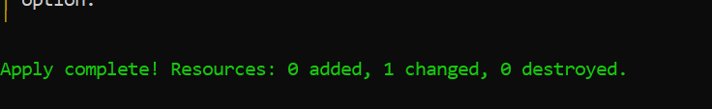

* task9_gitea_browser.png

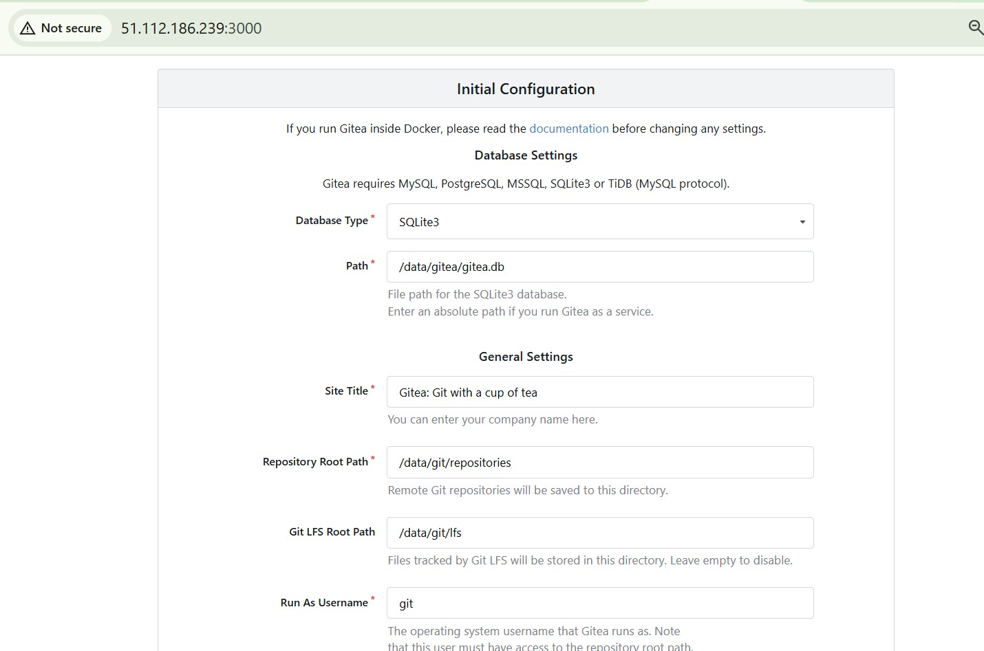

# Task 10 – Automating Ansible with Terraform (null_resource)

* task10_null_resource_main_tf.png

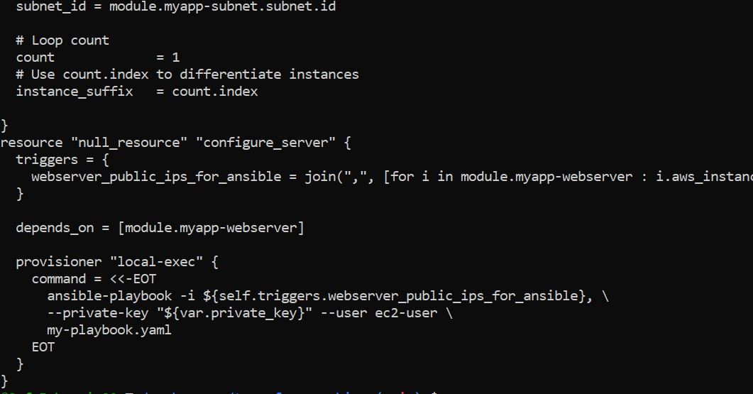

* task10_terraform_destroy_before_null.png

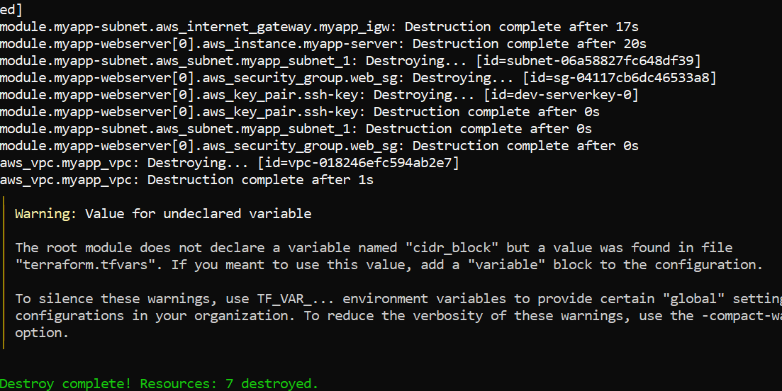

* task10_terraform_apply_with_local_exec.png

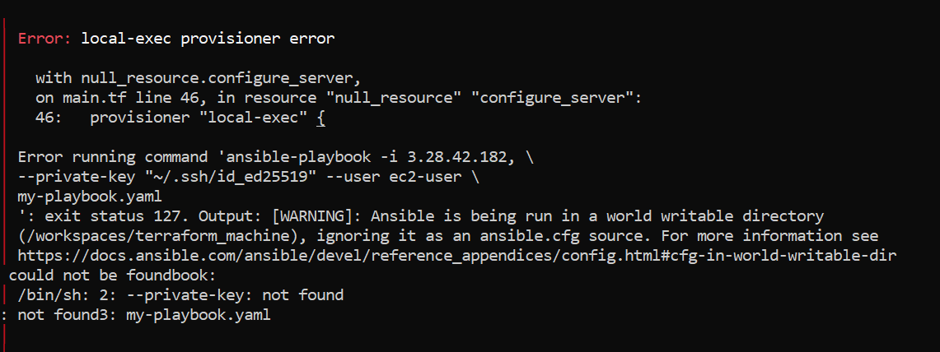

* task10_my_playbook_wait_for_ssh.png

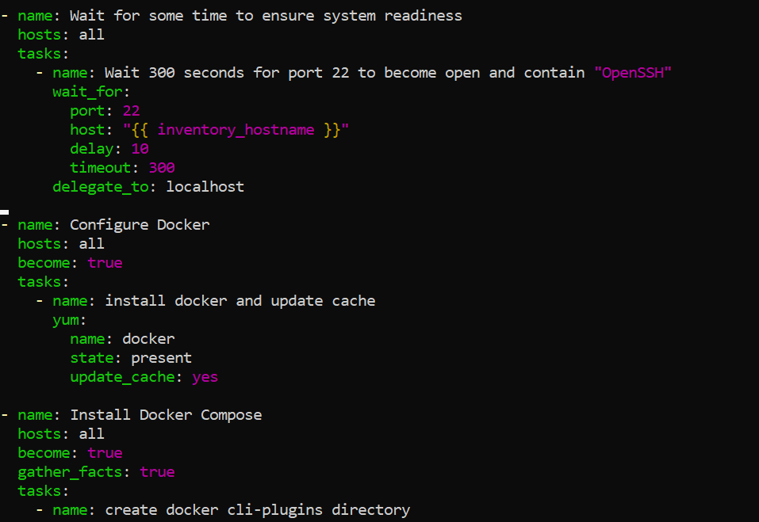

* task10_terraform_apply_after_wait.png

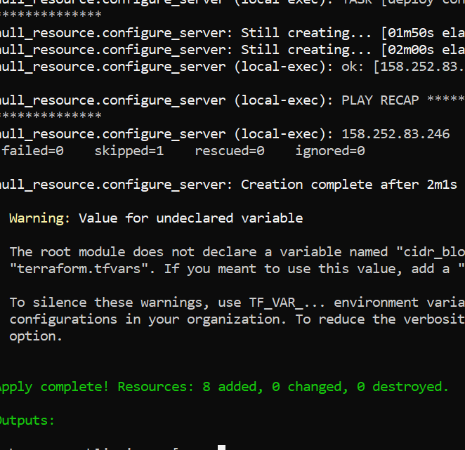

* task10_app_browser_post_null_resource.png



# Task 11 – Dynamic inventory with aws_ec2 plugin

* task11_ansible_cfg_aws_ec2.png

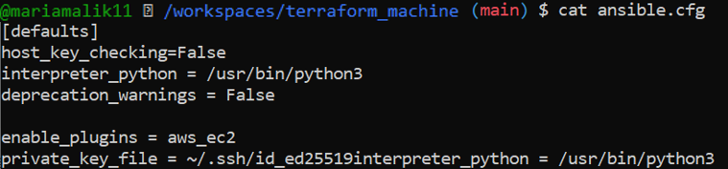

* task11_inventory_aws_ec2_created.png



* task11_inventory_aws_ec2_initial.png

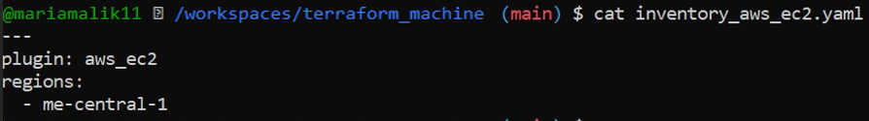

* task11_main_tf_dev_prod_modules.png

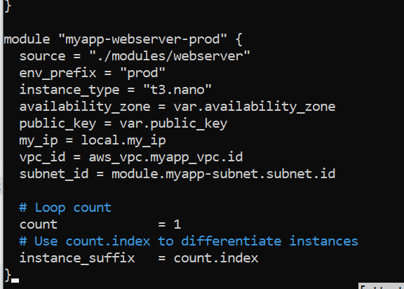

* task11_outputs_tf_dev_prod_ips.png

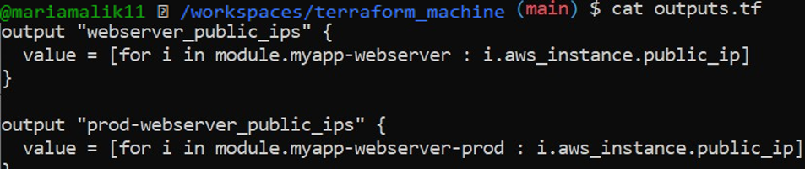

* task11_terraform_apply_dynamic_setup.png

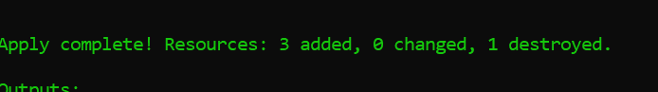

* task11_terraform_output_dynamic_ips.png

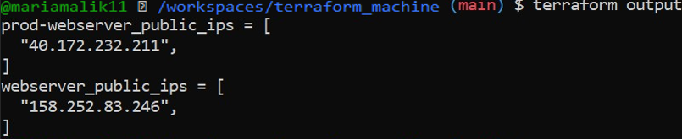

* task11_boto_install.png

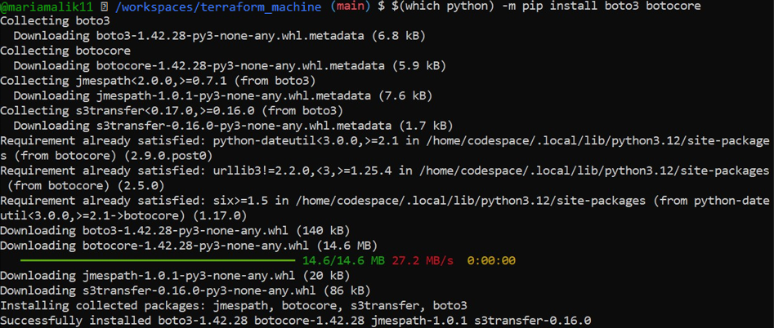

* task11_boto_version.png



* task11_ansible_inventory_graph_initial.png

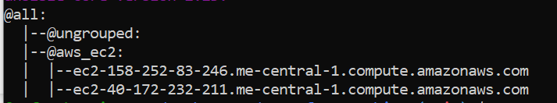

# Task 12 – Filtering EC2 instances by tags & instance type

* task12_inventory_aws_ec2_tag_groups.png

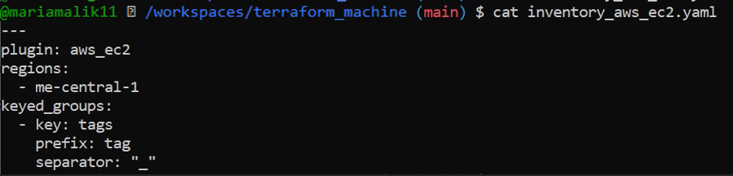

* task12_inventory_graph_tag_groups.png

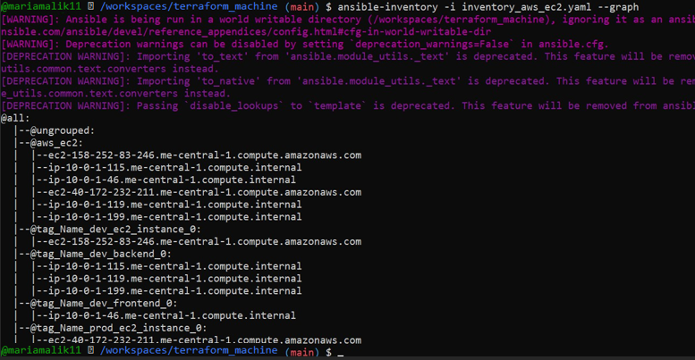

* task12_inventory_aws_ec2_instance_type_groups.png

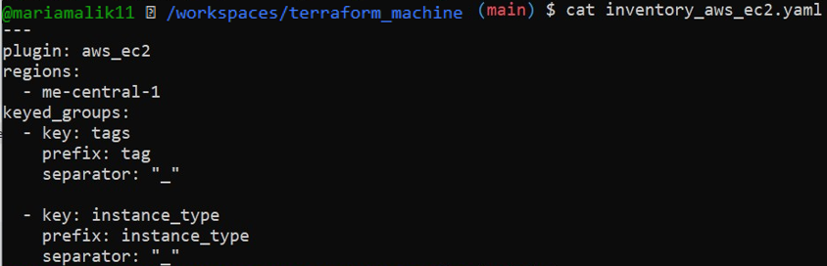

* task12_inventory_graph_full.png

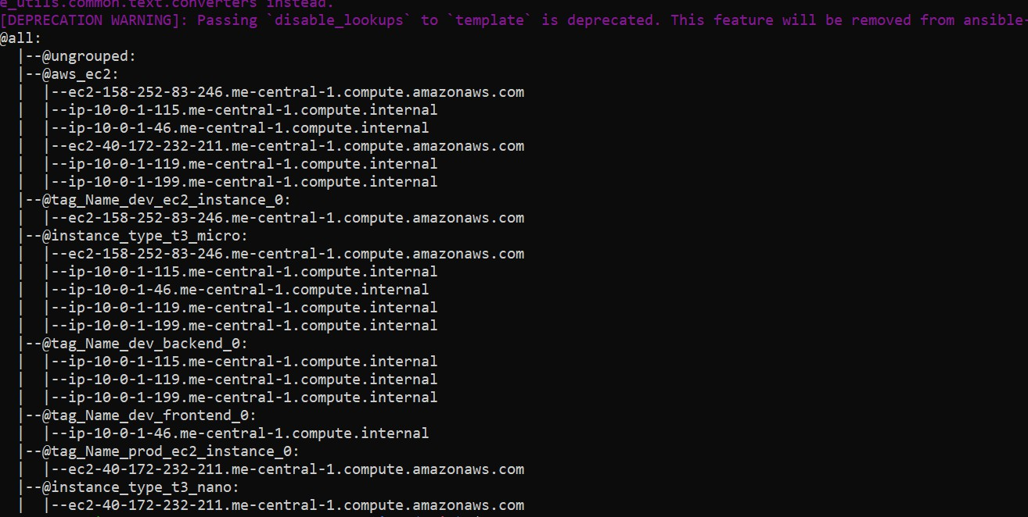

* task12_my_playbook_all_hosts.png

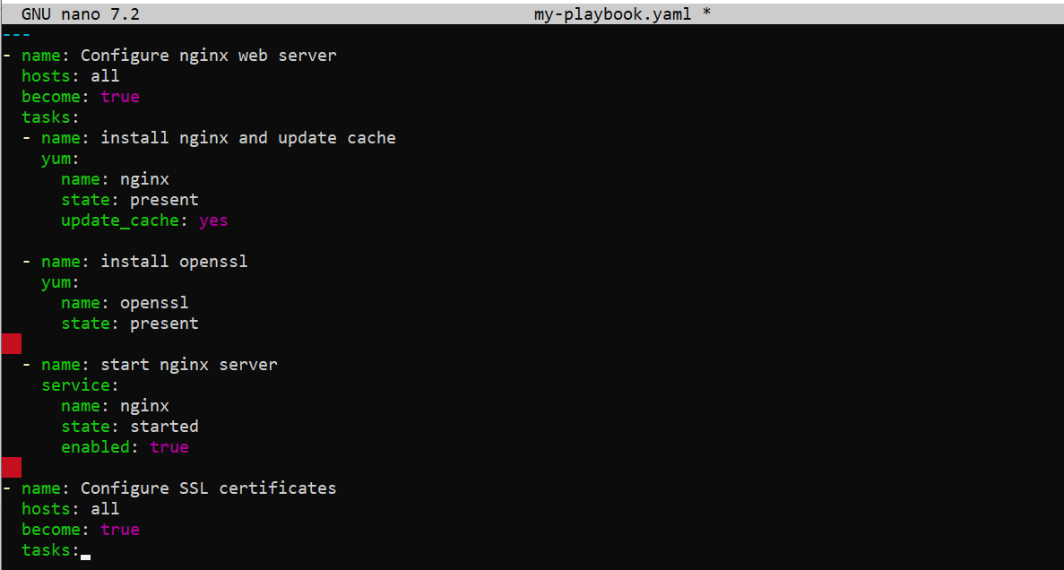

* task12_ansible_play_all.png

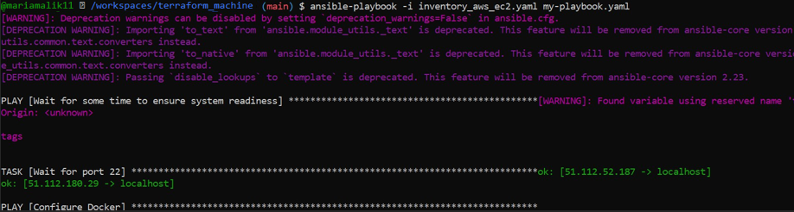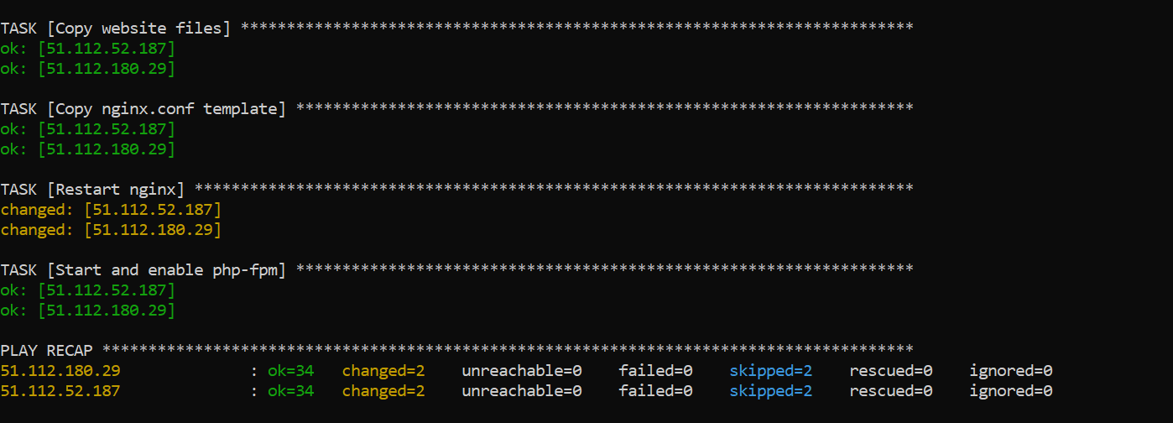

* task12_ansible_play_dev_only.png

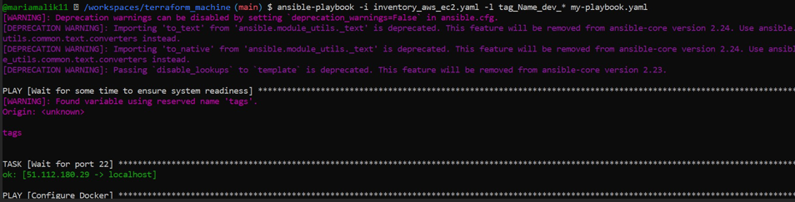

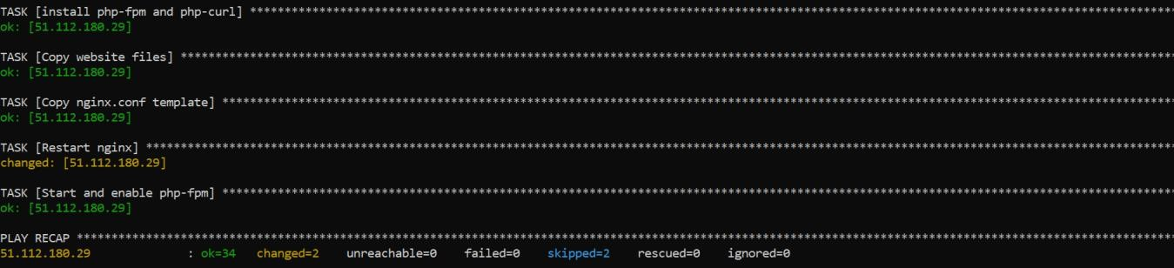

* task12_ansible_play_prod_only.png

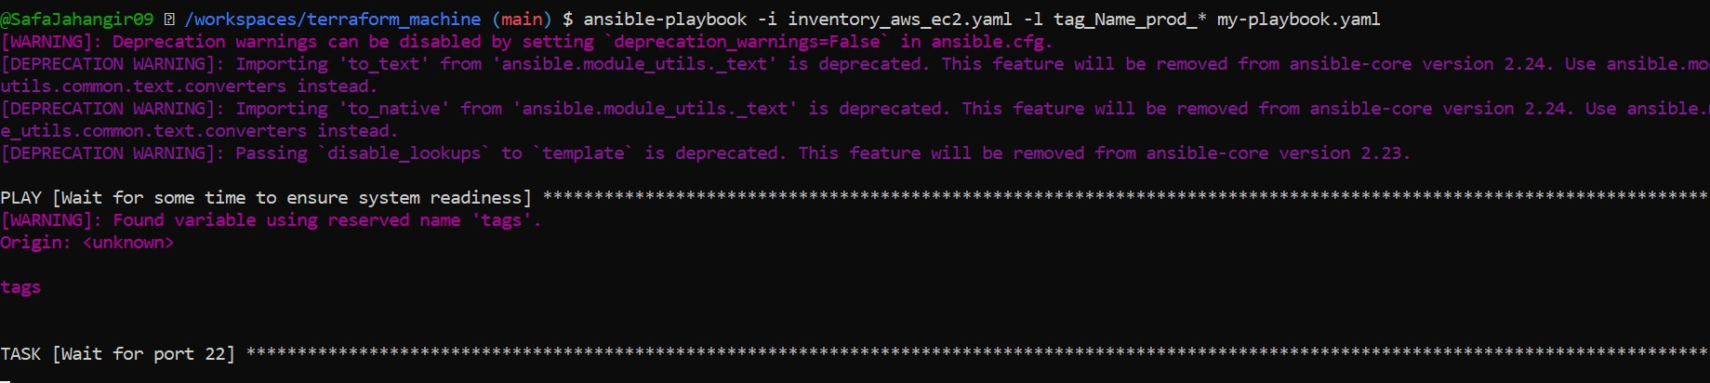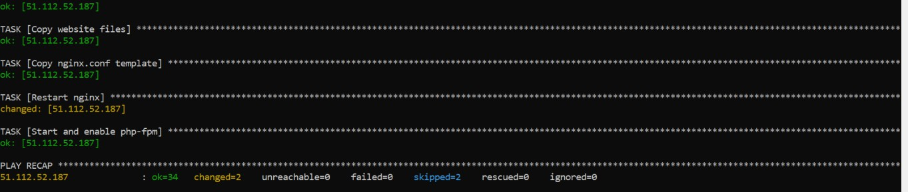

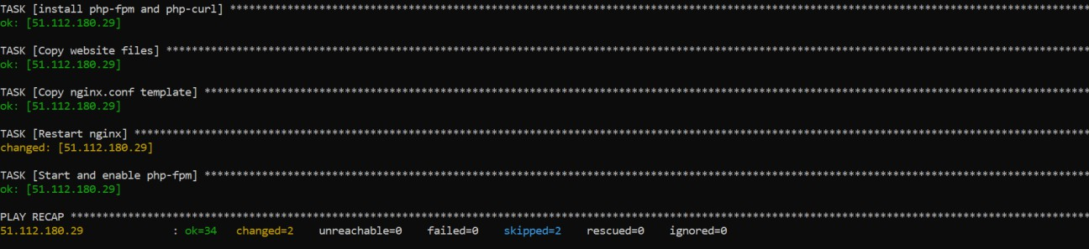

* task12_ansible_play_t3_nano.png

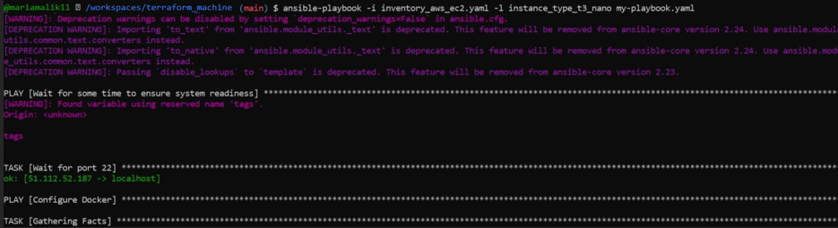

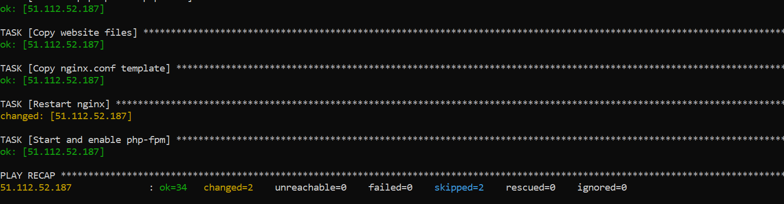

* task12_ansible_cfg_inventory_default.png



* task12_ansible_play_t3_nano_no_i.png

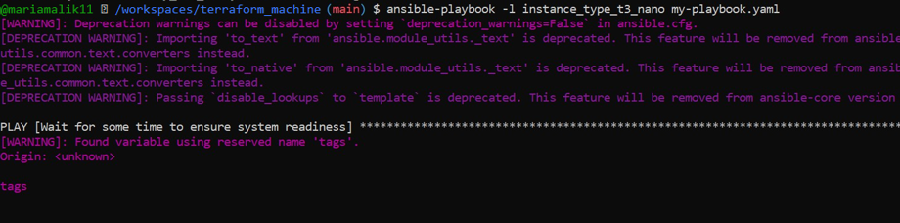

# Task 13 – Ansible roles: nginx, ssl, webapp

* task13_main_tf_single_dev.png

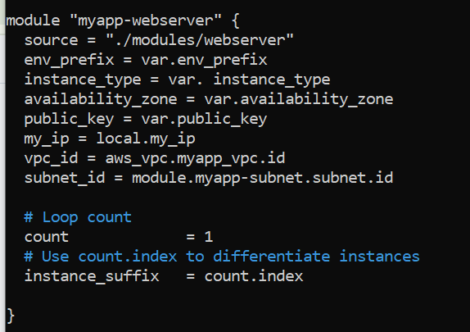

* task13_ansible_structure_created.png

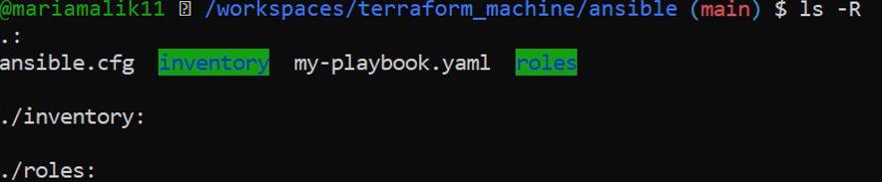

* task13_ansible_cfg_project.png

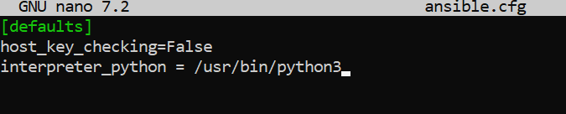

* task13_ansible_inventory_hosts.png

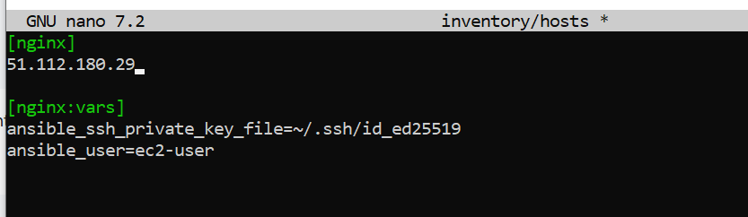

* task13_roles_created.png
* 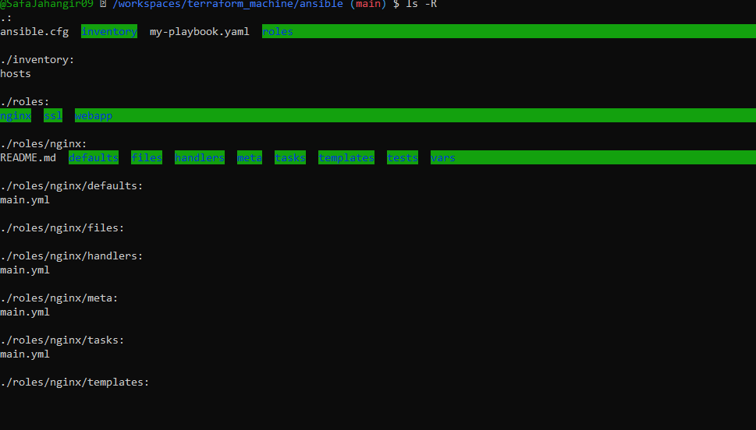
* task13_nginx_handlers_main.png

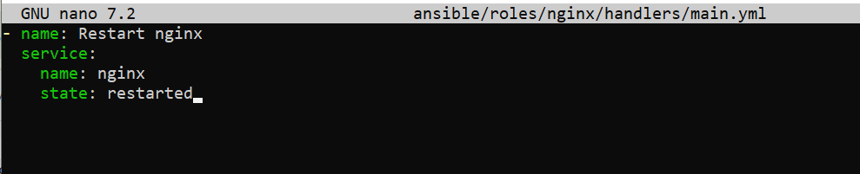

* task13_nginx_tasks_main.png

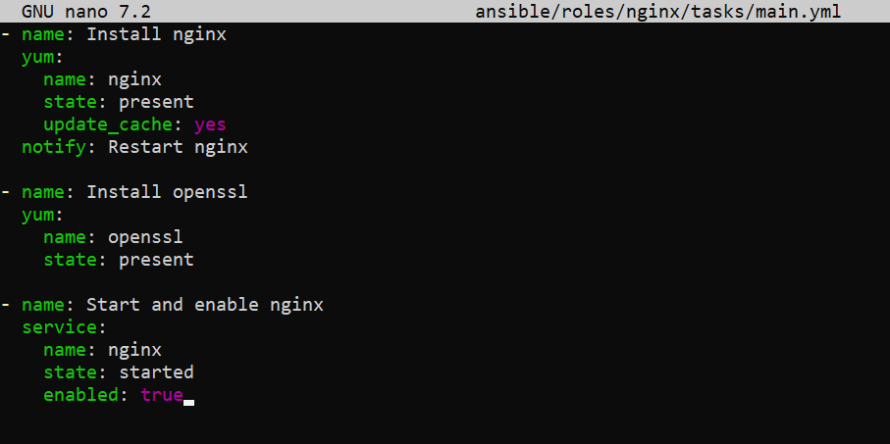

* task13_my_playbook_nginx_only.png

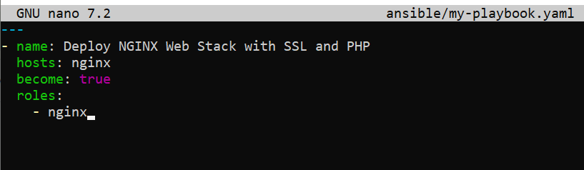

* task13_ansible_play_nginx_only.png
* 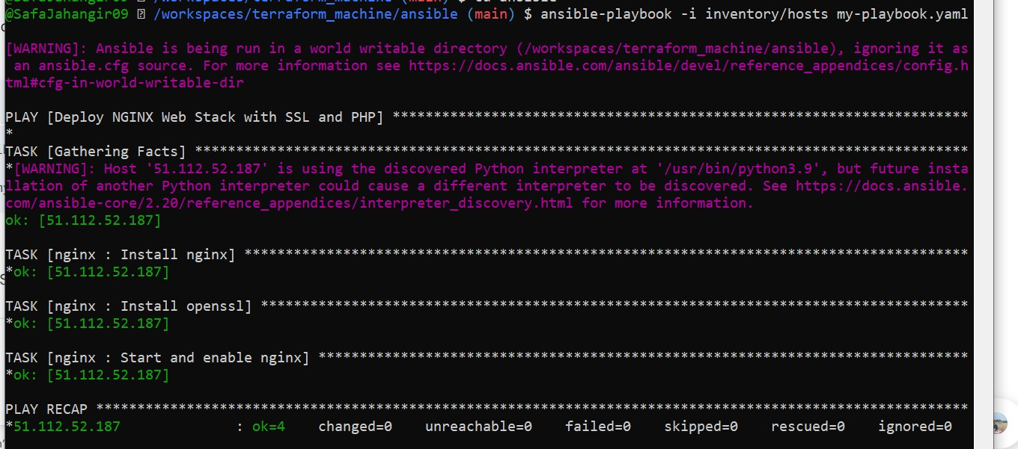
* task13_nginx_browser_roles.png

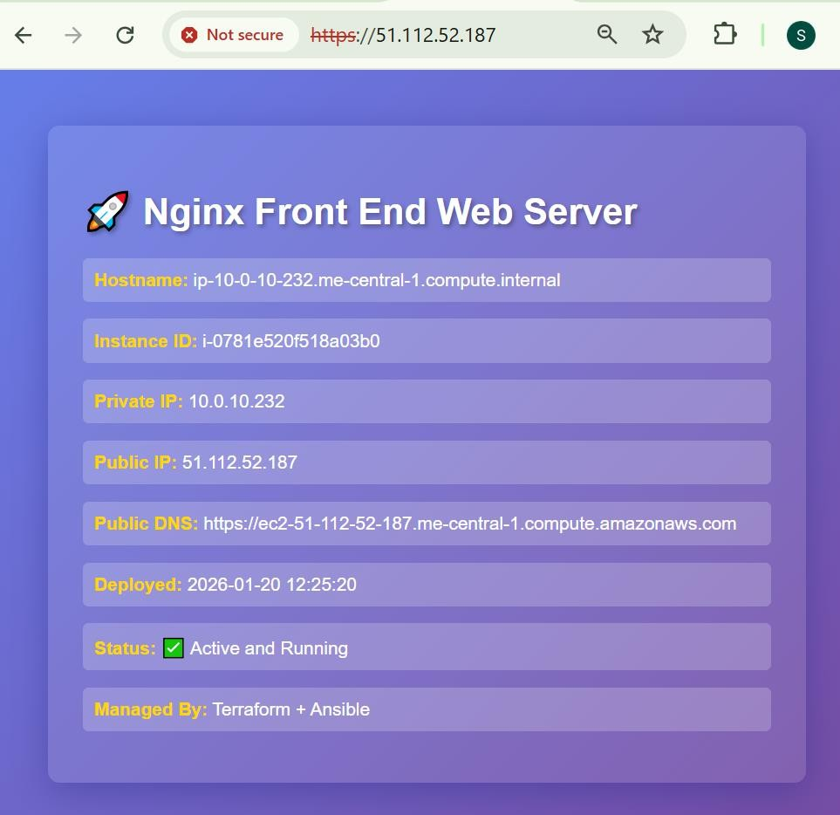

* task13_ssl_defaults_main.png

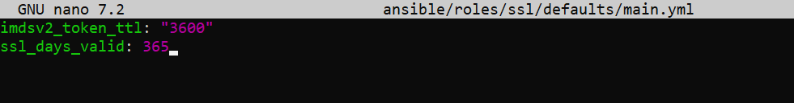

* task13_ssl_tasks_main.png

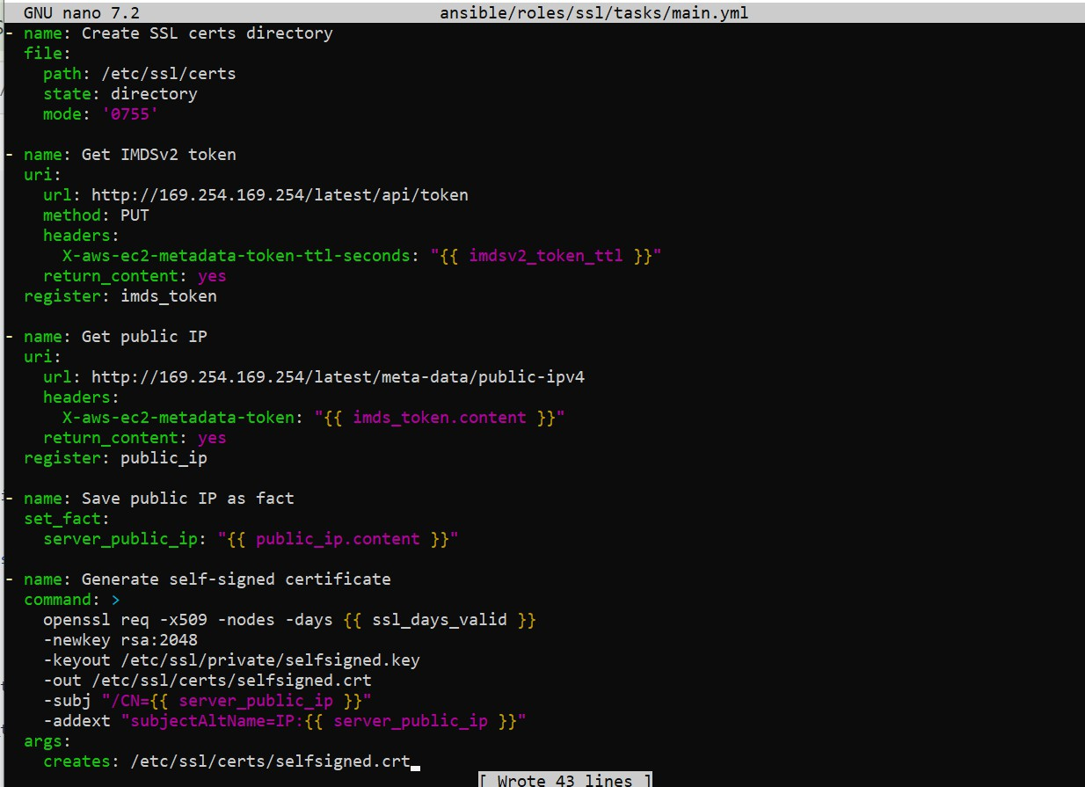

* task13_webapp_defaults_main.png

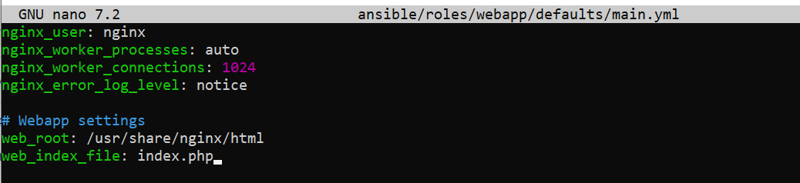

* task13_webapp_files_index_php.png

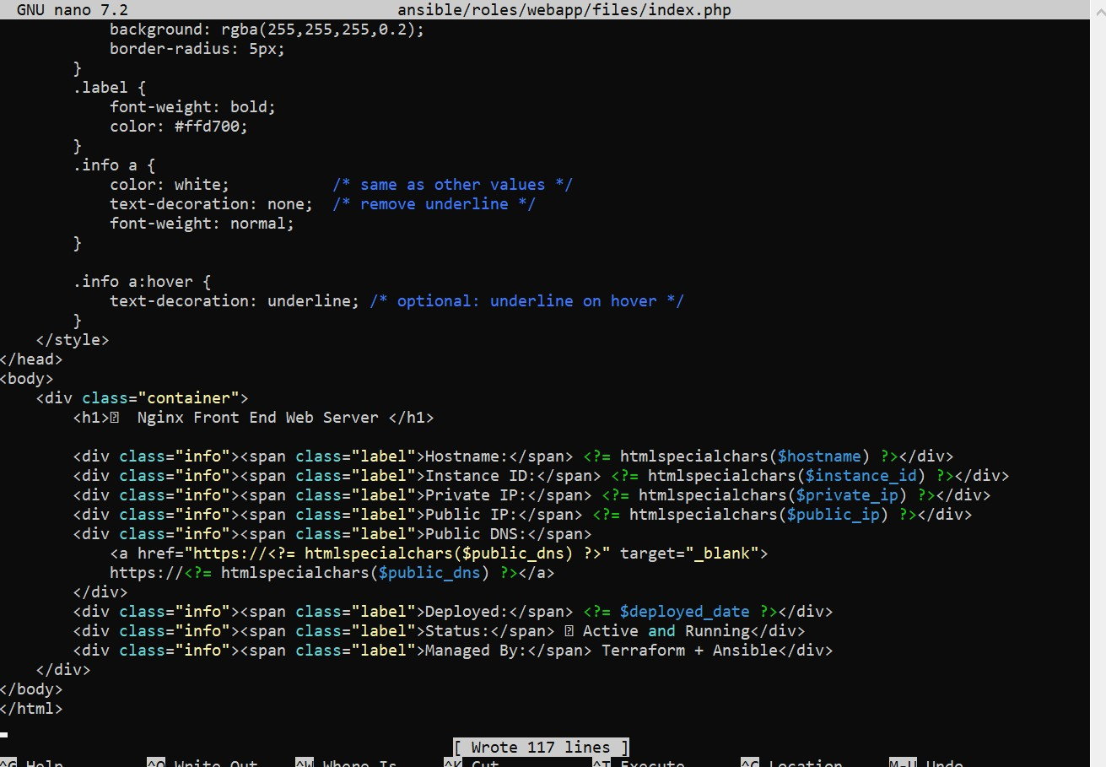

* task13_webapp_handlers_main.png

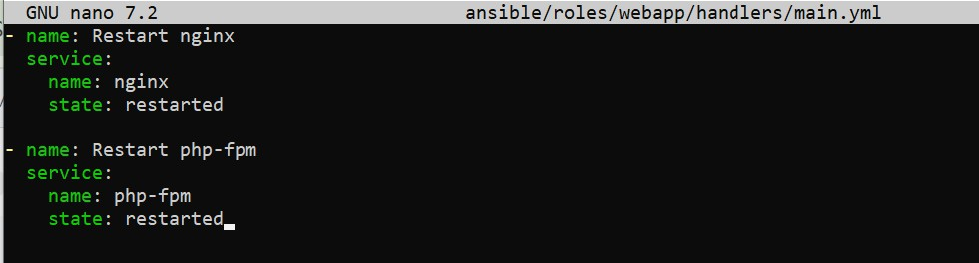

* task13_webapp_templates_nginx_conf.png

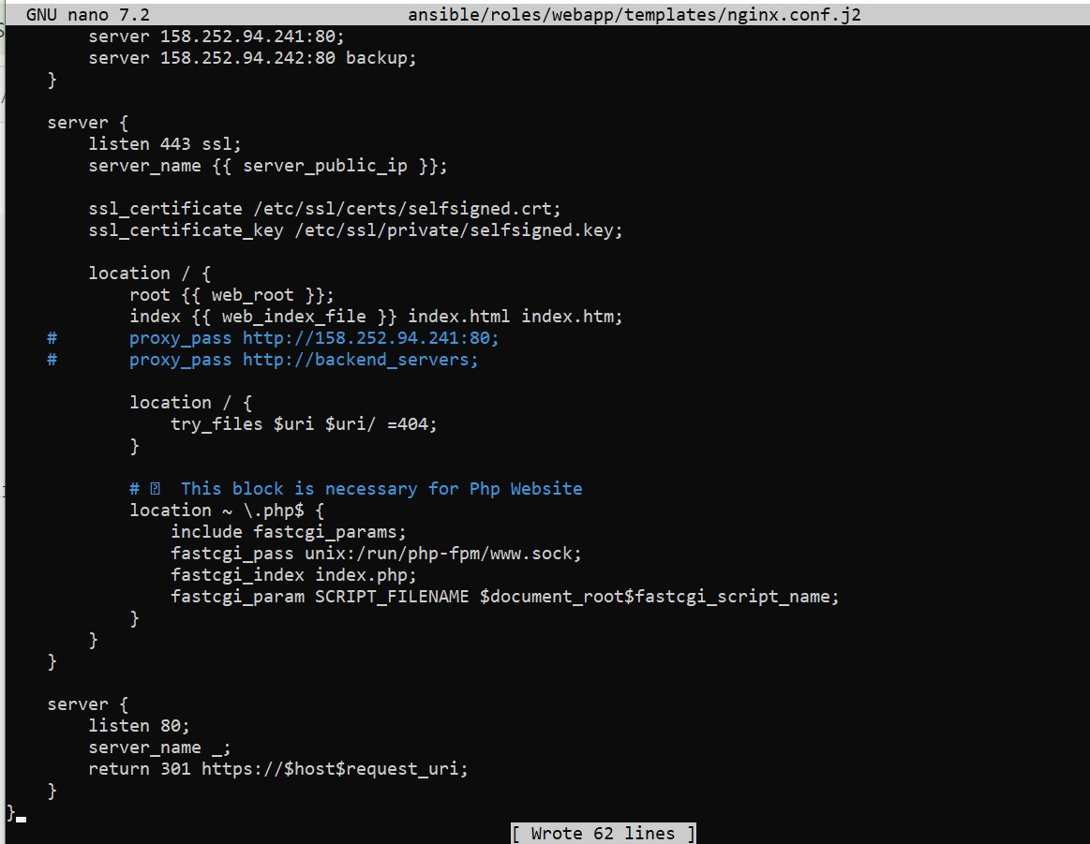

* task13_webapp_tasks_main.png

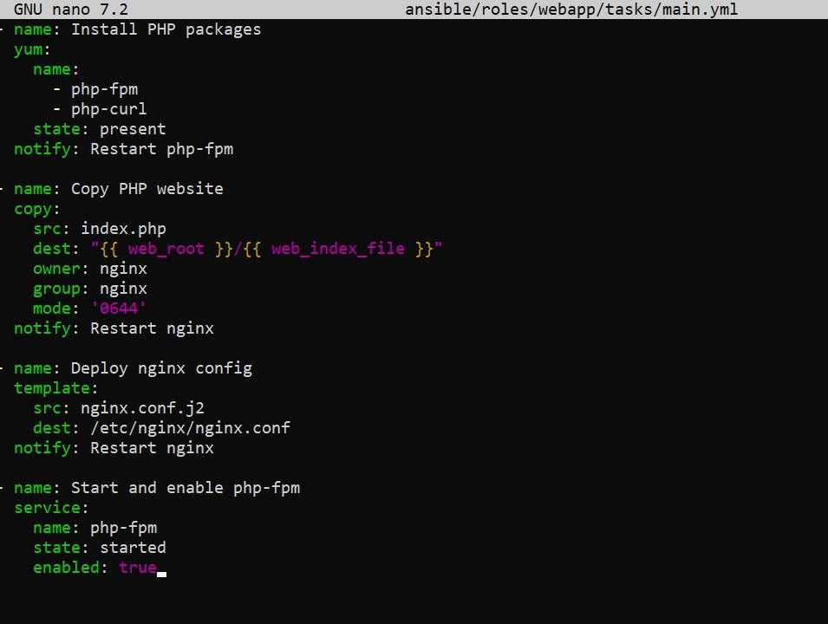

* task13_my_playbook_roles.png

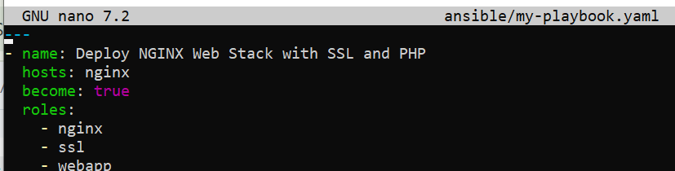

* task13_ansible_play_roles.png

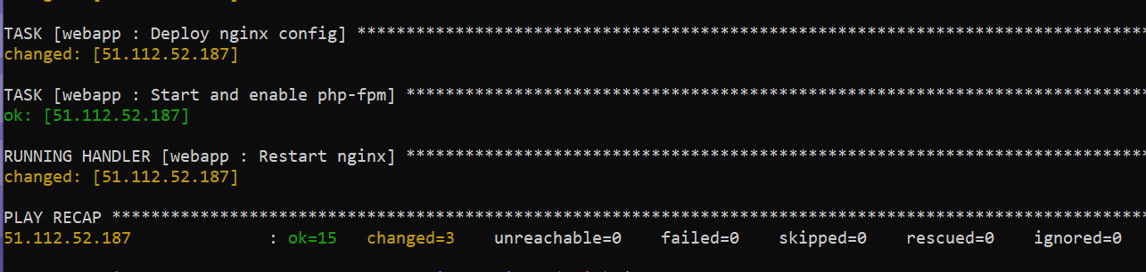

* task13_php_https_browser_roles.png

